HSEMR (Health Science Electronic Medical Records)- Use Case Diagram
*Legend: CRUD- Create, Read, Update, Delete
White use case- Student, Admin and Lecturer, either two or more can carry out the same task.
Blue use case- only applicable to student, Orange use case- only applicable to lecturer, Green use case- only applicable to Admin 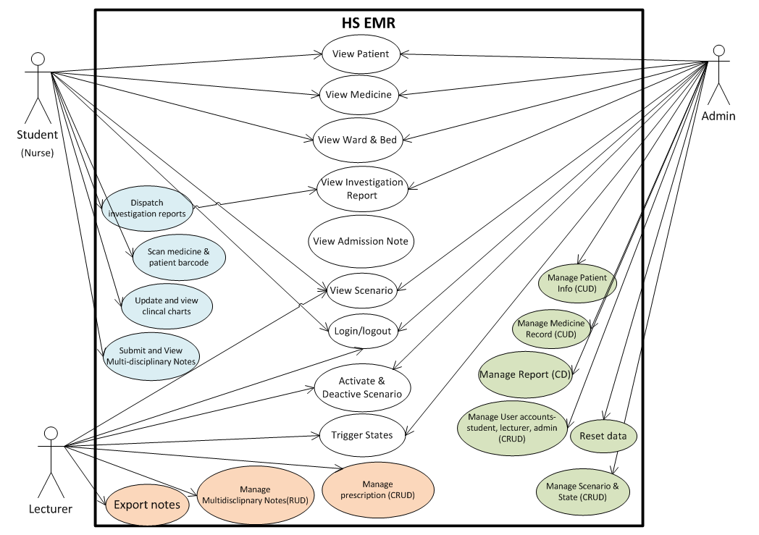
Use Case Description
Actors | Description
Student (Nurse) | Students will be using HSEMR for viewing, exchanging and submission of information. They are able to view information about the patient, medicine, scenario, ward, report and clinical charts using HSEMR. They can also submit their findings in the multi-disciplinary notes, request for reports and scan medicine and patient barcode before administering the medicine.
Lecturer | Lecturers can view the multi-disciplinary notes previously submitted by the students in HSEMR. Lecturers are in charge of activating and deactivating the scenario and the triggering of the patient’s states. In additional, they will be the one managing the prescription of the patient.
Admin | Admin will oversee the entire HS EMS, where they will view and manage the creation, updating, deletion of all the features in HS EMR except multidisciplinary notes. In additional, they will be responsible for managing user accounts which include student, lecturer and admin.
Note: The patient refers to a manikin in NP HS simulation lab.

Use Case Name | Login/Logout
Actors | Student, Lecturer, Admin
Brief Description | Students will play the role as either a nurse to login/logout to use the HSEMR. Students, Lecturers, Admin will use the password and user ID created by Admin.
Precondition | Actors must be present in NP classroom.
Post-Condition | The system will redirect Student, Lecturer, and Admin to their respective home page.
Basic Flow | Logs in with the correct user ID and password then the system responses by redirecting them to their respective home page. After completing their respective actions, when they decide to logout it should redirect them to the main page.
Alternative Flow | The system will show an error message if the actors failed to provide the right credentials.
Functional Area | Login/Logout

Use Case Name | View Patient
Actors | Student and Admin
Brief Description | Actors are able to View Patient information after they have successfully login.
Precondition | Actors must be present in NP classroom and be able to login.
Post-Condition | The system should display the patient information to the actors.
Basic Flow | Actors will login to view the patient records for the patient information such as name, gender, nric, dob, allergy.
Functional Area | View/Display

Use Case Name | View Medicine
Actors | Student and Admin
Brief Description | Actors are able to View Medicine after they have successfully login.
Precondition | Actors must be present in NP classroom and be able to login.
Post-Condition | The system should display the medicine information to the actors.
Basic Flow | Actors will login to view the medicine records for the medicine information such as the medicine name, dosage, route, medicine barcode.
Functional Area | View/Display

Use Case Name | View Ward & Bed
Actors | Student and Admin
Brief Description | Both actors are able to View ward after they have successfully login.  They will be presented with a 2D visualisation of the beds in the ward and the patient that is assigned to the bed.  Green indicates that the bed is available, while Grey indicates that the bed is occupied.
Precondition | Actors must be present in NP classroom and be able to login.
Post-Condition | The system will display the ward visualization.
Basic Flow | Actors will login to view the ward where they will see the patient assigned to each bed and the availability of the beds
Functional Area | View/Display

Use Case Name | View Scenario
Actors | Student, Lecturer, Admin
Brief Description | Actors are able to View Scenario after they have successfully login.  However, Students are only able to view the latest activate scenario. While the Lecturer and Admin is able to view ALL scenarios to decide which one to release to the student.
Precondition | Actors must be present in NP classroom and be able to login.
Post-Condition | The system will display the scenario information.
Basic Flow | Actors will login to view the scenario information that consists of case id, case description and admission info.
Functional Area | View/Display

Use Case Name | View Investigation Report
Actors | Student and Admin
Brief Description | Actors are able to View Investigation report after they have successfully login by clicking on the report link.
Precondition | Actors must be present in NP classroom and be able to login.
Post-Condition | The system will display the report by retrieving the file from the database.
Basic Flow | Actors will login to view the report that consists of example, ECG, X-Ray, FBC that will be displayed in the form of a picture once the actor selects the report link to open.
Functional Area | View/Display

Use Case Name | Manage Multi-disciplinary notes and Export notes
Actors | Lecturer
Brief Description | Lecturer is able to View, Update and delete student’s submission notes after they have successfully login and also export the notes once they have viewed.
Precondition | Actors must be present in NP classroom and be able to login.
Post-Condition | The system will display the multi-disciplinary notes and depending on the lecturer action to update or delete the database will be updated.
Basic Flow | Lecturer will view, update and delete the multi-disciplinary submission that contains the practical group, the group member names and notes. Lecturer will have an option to export the notes into a document for safekeeping on their laptops for grading purpose.
Functional Area | View, Update, Delete

Use Case Name | Activate & Deactivate Scenarios
Actors | Lecturer and Admin
Brief Description | Both actors are able to Activate & Deactivate Scenarios after they have successfully login.  Lecturer will be shown the Scenario in terms of clicking on picture before viewing the information of the scenarios, while Admin will be presented with a table view of the scenario information upon clicking case information.
Precondition | Actors must be present in NP classroom and be able to login.
Post-Condition | The system upon selection of action, the database needs to be updated with the current status of the scenario, whether is activated or not.
Basic Flow | Actors will login to view the scenario information, after which they can click on either activate or deactivate button. A successful message will be shown to the actors and the status will show “activated” or “deactivated” to the user.
Functional Area | Update

Use Case Name | Trigger States
Actors | Lecturer and Admin
Brief Description | Both actors are allowed to trigger the states that are tied to a particular scenario. Depending on the state selected by the actors, the student portal will change accordingly.
Precondition | Actors must be present in NP classroom and be able to login.
Post-Condition | Upon the actor triggering of state, the system would need to show the correct state to the student portal changing information such as doctor order and reports and also inform the actors that the state has been updated.
Basic Flow | Actors will need to select the state they will activate from the list of states displayed. Upon selecting a successful message will show that the state is updated.
Functional Area | Update

Use Case Name | Manage prescription
Actors | Lecturer
Brief Description | Lecturer will be in charge of creating, updating and deleting the prescriptions.
Precondition | Actors must be present in NP classroom and be able to login.
Post-Condition | The system will show the prescription information, once the Lecturer decides to update or delete the database will update accordingly and the page will reflect accordingly.
Basic Flow | Lecturer will view information such as doctor order and doctor name and frequency of the medication to administer and also be able to update or delete the prescription which will then show a successful message.
Alternative Flow | The system will show an error message if the system is unable to update, create or delete to the database or the field’s value are keyed in wrongly or left blank unintentionally.
Functional Area | View, Create, Update, Delete

Use Case Name | Manage Patient Info
Actors | Admin
Brief Description | Admin is able to create, update and delete Patient information after they have successfully login and navigate to the patient management page.  Update Patient basic information will consists of updating the name, gender, DOB, allergy, NRIC. Once admin have updated, they will submit their changes for the update to be stored in the database.  Admin can also create a new patient and delete and existing patient.
Precondition | Actors must be present in NP classroom and be able to login.
Post-Condition | The system will display the patient fields that are editable for users to update and upon submission the changes must be reflected and updated in the database. Also, if Admin decides to create or delete, the system will insert or delete the record in the database respectively.
Basic Flow | Admin logs in and navigate to patient management, depending on the action he/she chooses, respective successful message will be shown to the actors and the respective update, insertion and deletion will be done to the database.
Functional Area | Create, Update, Delete

Use Case Name | Manage Medicine
Actors | Admin
Brief Description | Admin is able to Update Medicine information after they have successfully login and navigate to the medical management page.  Once the Admin have updated, they will submit their changes for the update to be stored in the database. Admin will have to enter medicine details if they were to create a new medicine.
Precondition | Actors must be present in NP classroom and be able to login.
Post-Condition | The system will display the Medicine fields that are editable for users to update and upon submission the changes must be reflected and updated in the database. Also creation and deletion of the medicine will be done to the database depending on the action of the Admin.
Basic Flow | Actors will login to view the Medicine information choose the medicine he/she wish to update the relevant fields, create or delete. A successful message will be shown to the admin upon completion.
Functional Area | Create, Update, Delete

Use Case Name | Manage Report
Actors | Admin
Brief Description | Admin is able to Create and delete the report, they create by uploading the report to the website. And delete by clicking a button to delete the record they wish to remove.
Precondition | Actors must be present in NP classroom and be able to login.
Post-Condition | The system will stored the reports of the uploaded entries made by the Admin, also should permanently remove the reports which are no longer required from the database.
Basic Flow | Admin will login the admin portal to manage report by choosing which report they will want to upload with the ‘browse’ function upon uploading an successful message will be shown. If admin clicks on delete, the system will show a confirmation before proceeding to delete successfully.
Functional Area | Create, Delete

Use Case Name | Reset Data
Actors | Admin
Brief Description | The admin is able to reset the multidisciplinary notes and vital signs previously entered by the students.
Precondition | Admin must be present in NP classroom and be able to login.
Post-Condition | The system will need to delete all the information entered by the student in the multidisciplinary notes and vital signs from the database.
Basic Flow | Lecturers will need to login to their admin page, where they will navigate to the Medicine management page to reset the quantity of the medicine.  Once successful a message would be shown to indicate that the quantity is updated.
Functional Area | Reset/Delete

Use Case Name | Manage User Accounts
Actors | Admin
Brief Description | The Admin is able to Manage User accounts where they can:  - Create new student, lecturer, admin account  - View Student, lecturer, admin account  - Edit Student, lecturer, admin account  - Delete Student, lecturer, admin account
Precondition | Lecturer must be present in NP classroom and be able to login.
Post-Condition | The system will create, update, and delete the user record in the database respectively.
Basic Flow | The Admin will need to login to their admin page, where they will navigate to user management to perform create, view, update and delete the user account. Depending on which user is selected, the information of the user will be populated on the page and they can choose to create, update or delete after which a successful message will be shown.
Functional Area | Create/Update/Delete/View

Use Case Name | Submit Consultation Notes
Actors | Student
Brief Description | The student is able to key in consultation notes (such as what they have done for the lab, the condition of the patient, etc) for the respective patient after they have successfully logging in and navigate to the patient management page.
Precondition | Student must be present in NP classroom and be able to login.
Post-Condition | The system will stored the consultation notes of the patient.
Basic Flow | Students will login to HSEMR, go to patient management page where they can create the consultation notes for the selected patient.  Upon creation of the consultation note, a successful message will be shown to the student which indicates that the information is stored. They will also be able to view past consultation groups from the other groups to see where they have left off from.
Functional Area | Create

Use Case Name | Scan Medicine and patient barcode
Actors | Student
Brief Description | The students are able to Administer Medicine to the patient by first scanning the medicine and patient barcode to see if they match before administer the medicine.
Precondition | Student must be present in NP classroom and be able to login.
Post-Condition | The system will need to validate that this medicine is for this patient.
Basic Flow | Students will need to login and then proceed to Patient Management page, medicine tab where they can view the medicine required for the patient, dosage and route. Once successful a message would be shown to indicate that the medicine is given to the patient.
Alternative Flow | The system will show an error message if the system is unable to match the patient barcode to the medicine meaning the student has actually took the wrong medication.
Functional Area | Create/Update

Use Case Name | Update and view clinical charts
Actors | Student
Brief Description | The students are able to enter the patient vital signs from their findings and proceed to submit the data. From the data, student are able to see charts of the patient vital signs such as temperature, blood pressure, etc.
Precondition | Student must be present in NP classroom and be able to login.
Post-Condition | The system will need to generate charts based on the input of the student and store those input in the database.
Basic Flow | Students will need to login and then proceed to Patient Management page, clinical charts tab where they can view last updated vital signs and textbox for them to key in the findings.
Alternative Flow | The system will show an error message if vital signs values are out of a certain range or the data are of incorrect type.
Functional Area | View and Update

